**Mandatory Disclosure**

**Mandatory Disclosure** : updated on

1. **AICTE file no**. :730-50-705(E)/ET/2008

**Date & Period of last approval** : 25th April 2019, 2019-2020.

1. **Name of the Institution & Address** : SRI ANNAMACHARYA INSTITUTE OF TECHNOLOGY   
    AND SCIENCE
2. 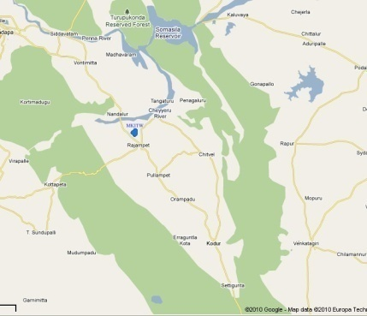**Address**  : New Boyanapalli, Rajampet

**City & Pin code** : Rajampet-516126

**State**  : Andhrapradesh

**Longitude & Latitude** : 14013’10.84”N & 79008’17.84”E

**Phone Numbers with STD Code** : 08565-251490

**Fax Number with STD Code** : 08565-251491

**Office hours at the Institute** : 9:00AM to 5.00PM

**Academic hours at the Institution** : 8.30AM to 4.30 PM

**E-mail** : mkitrjpt@gmail.com

**Website** : [www.satsrjpt.com](http://www.satsrjpt.com)

**Nearest Railway Station (dist in KM)** : Rajampet – 05km

**Nearest Airport (dist in KM)** : Tirupati – 90km

1. **Type of Institution** : Private - Self Financed

**Category (1) of the Institution** : Non Minority

**Category (2) of the Institution** : Co-Education

1. **Name of the organization running**

**the institution** : Sree Tallapaka Annamacharya Educational Society

**Type of the organization** : Society

**Address of the organization** : New Boyanapalli, Rajampet, Kadapa dt-A.P.516126.

**Registered with**  : Societies Registration act XXI of 1860

**Registration date** : 18-08-1982

**Website of the organization** : www.staes.com

1. **Name of the affiliating University** : JNT University, Anantapur

**Address**  : Anantapur

**Website**  : [www.jntuanantapur.org](http://www.jntuanantapur.org)

**Latest affiliation period** : 2019-2020

1. **Name of the principal** : Dr. S. Sreenivasulu

**Exact Designation** : Principal

**Phone number with STD Code** : 08565-251490

**Fax number with STD code** : 08565-251491

**E-mail** :seena.sane@gmail.com

**Highest Degree** : Ph.D.

**Field of specialization** : Mechanical Engineering

1. **Governing Board Members** : Twice in a year.

**Frequency of meetings**

1. **Academic Advisory Body** : 1. Principal,

**Frequency of meeting**  2. Concerned Head of the Departments

: 3. Senior Professors,

Once in a month

1. **Organizational Chart** :

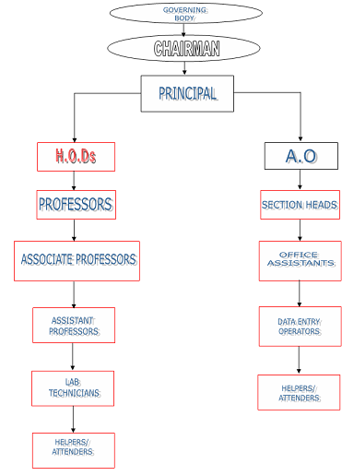

1. **Student feedback mechanism on**

**Institutional Governance/faculty**

**Performance** : The feedback will be obtained on the performance of the faculty once in a semester in a prescribed format to take necessary steps to improve the academic performance of the faculty for better results. The feedback details will be given to the concerned faculty to correct themselves in case of any lapses in certain aspects.

1. **Grievance redressal mechanism for**

**Faculty, staff and students** : A Grievance redressal cell will be established under the Chairmanship of a senior Professor with two other faculties as members to enquire on the any grievance of the faculty, staff and students may suggest redressal measures to the Management through Principal. Meeting of class representatives with the Principal and the members of CAC is arranged once in two months. The problems raised by them are noted and required corrective action is taken. The problems of the faculty brought during all faculty meetings or otherwise, staffs when brought to the notice of college authorities are attended to by the college management.

1. **(a) Name of the Department** : Electronics and Communication Engineering

Course : ECE

Level : UG

1st Year of approval by the Council : 60

2019-20 2018-2019 2017-18 2016-17

Year wise sanctioned Intake : 60 60 120 180

Year wise Actual admissions : 0 0 10 4

Cut off marks-General quota :

Min. Rank: 0 0 46562 59521

Max. Rank: 0 0 250081 238621

% Students passed with Distinction : -- 54.3% 56.68% 40.28%

% Students passed with First Class : -- 33.4% 28.28% 18.21%

Students placed : Not applicable --

Average Pay package, Rs/Year : Not applicable

Students opted for Higher Studies : Not applicable

Accreditation Status of the Course : Not eligible yet

Doctoral Courses : Not applicable

Foreign Collaborations, if any : Not applicable

Professional Society Memberships : Nil

Professional activities : Nil

Consultancy activities : Nil

Grants fetched : Nil

Departmental Achievements : Got Prathibha Award in M.Tech Embedded   
 Systems

Distinguished Alumni : --

**(b)** **Name of the Department** : **Computer Science Engineering**

Course : CSE

Level : UG

1st Year of approval by the Council : 60

2019-20 2018-2019 2017-18 2016-17

Year wise sanctioned Intake : 60 60 90 120

Year wise Actual admissions : 11 22 22 17

Cut off marks-General quota Min Rank: 54323 75768 60262 55987

Max Rank: 280111 275485 265275 262809

% Students passed with Distinction : -- 42.12% 56.5% 35.21%

% Students passed with First Class : -- 17.83% 32.4% 25.26%

Students placed : Not applicable

Average Pay package, Rs/Year : Not applicable

Students opted for Higher Studies : Not applicable

Accreditation Status of the Course : Not eligible yet

Doctoral Courses : No

Foreign Collaborations, if any : Nil

Professional Society Memberships : Nil

Professional activities : Nil

Consultancy activities : Nil

Grants fetched : Nil

Departmental Achievements : Nil

Distinguished Alumni : --

**(d)** **Name of the Department** : Electrical and Electronics Engineering

Course : EEE

Level : UG

1st Year of approval by the Council : 30

2019-20 2018-2019 2017-18 2016-17

Year wise sanctioned Intake : 30 30 48 60

Year wise Actual admissions : 0 0 0 0

Cut off marks-General quota Min: 0 0 0 NA

Max: 0 0 0 NA

% Students passed with Distinction : -- 52% 74.25% NA

% Students passed with First Class : -- 20% 12.4% NA

Students placed : Not applicable

Average Pay package, Rs/Year : Not applicable

Students opted for Higher Studies : Not applicable

Accreditation Status of the Course : Not eligible yet

Doctoral Courses : No

Foreign Collaborations, if any : Nil

Professional Society Memberships : Nil

Professional activities : Nil

Consultancy activities : Nil

Grants fetched : Nil

Departmental Achievements : Nil

Distinguished Alumni : Nil

**(e)** **Name of the Department** : Master of Business Administration

Course : MBA

Level : PG

1st Year of approval by the Council 60

2019-20 2018-2019 2017-18 2016-17

Year wise sanctioned Intake : 60 60 60 Not Applicable

Year wise Actual admissions : 39 5 60 Not Applicable

Cut off marks-General quota Min : 32956 75687 36524 Not Applicable

Max : 201532 198532 175632 Not Applicable

% Students passed with Distinction : -- 65.21% Not Applicable

% Students passed with First Class : -- 32.51% Not Applicable

Students placed : Not applicable

Average Pay package, Rs/Year : Not applicable

Students opted for Higher Studies : Nil

Accreditation Status of the Course : Nil

Doctoral Courses : No

Foreign Collaborations, if any : Nil

Professional Society Memberships : Nil

Professional activities : Nil

Consultancy activities : Nil

Grants fetched : Nil

Departmental Achievements : Nil

Distinguished Alumni : Nil

1. Name of Teaching Staff :

Designation :

Qualification with Class /Grade : UG PG PhD

Total Experience in Years : Teaching: Industry: Research:

Papers Published : National International

Papers Presented in Conferences : National International

PhD Guide? Give field & University : Field University

PhDs/Projects Guided : PhDs Projects at Mater level:

Books Published/IPRs/Patents :

Professional Memberships :

Consultancy Activities :

Awards :

Grants fetched :

Interaction with Professional Institutions:

1. **Admission Quota :**

**Entrance test/admission criteria** : 70% of the sanctioned seats are filled by the government strictly based on the rank obtained in EAMCET and ICET examination as per the rules of reservation. The remaining 30% of seats are filled by the management. Generally the institute will issue a notification for admission under management quota and call for applications from the eligible candidates. Based on the merit, the admissions will be made. The APSCHE will fix-up a cutoff date for admissions under management quota. After the cutoff date the list of candidates admitted under management quota will be submitted to APSCHE for its approval.

**Cut off/last candidate admitted** : A student should score minimum 40% marks in admission test to be conducted by the institutions, if any.

2019-20 2018-2019 2017-18 2016-17

: 287116 ***285025*** ***285214*** ***262809***

Fee in rupees : 2019-20 2018-2019 2017-18 2016-17

***38200*** ***38200*** ***38200-00 38200-00***

Number of Fee Waivers offered : Nil

Admission Calendar : The calendar for admission against management / vacant seats is fixed by the APSCHE, A.P.

PIO quota : **No**

1. **Infrastructural information** :

|  |  |
| --- | --- |
| Classroom/Tutorial room facilities: |  |
| Laboratory Details: |  |
| Computer Centre facilities: |  |
| Library facilities |  |
| Auditorium/Seminar Halls/Amphi |  |
| Cafeteria |  |
| Indoor Sports facilities |  |
| Outdoor sports facilities |  |
| Gymnasium facilities |  |
| Facilities for disabled |  |
| Any other facilities |  |

1. **Boys Hostel** : Not applicable

**Girls Hostel** : No

*Medical & other Facilities at Hostel : Not applicable*

1. **Academic Sessions** : **Academic Calendar**

As per JNTUA, Anatapuramu.

**Examination system, Year/ Sem** : For all years semester pattern

**Period of declaration of results**  : Within a month from completion date of exams.

1. **Counseling / mentoring :** Counseling for the students who are academically

poor at regular intervals by HOD and Professionals

**Career Counseling :** Career counseling done by Experts from different

industries.

**Medical facilities :** Available

**Student Insurance : Yes**

1. **Students Activity Body**

**Cultural Activities : Dance, Singing etc**

**Sports activities : Indore and outdoor games are available**

**Literary activities : Essay Writing, elocution are conducted twice in a**

**year**

**Magazine/ Newsletter : Available**

**Technical activities /TechFest : --**

**Industrial Visits / Tours : Amaron Batteries Industries**

**Alumni activities : --**

1. **Name of the Information Officer for RTI: Dr. S. Sreenivasulu**

**Designation : Principal**

**Phone number with STD code : 08565-251490, 9246999882**

**FAX number with STD code : 08565-251491**

**Email : seena.sane@gmail.com**